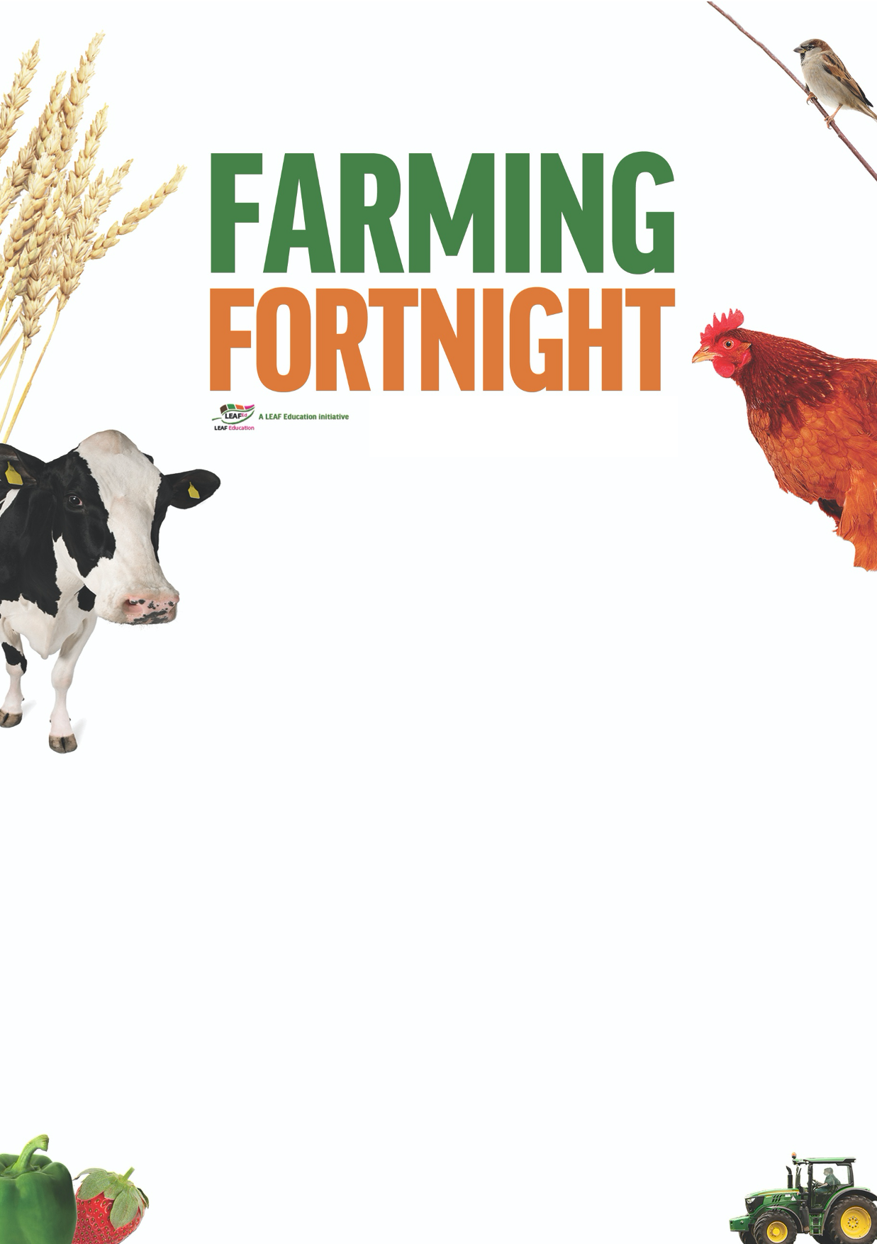
Teacher’s notes

Are you getting your 5 a day?

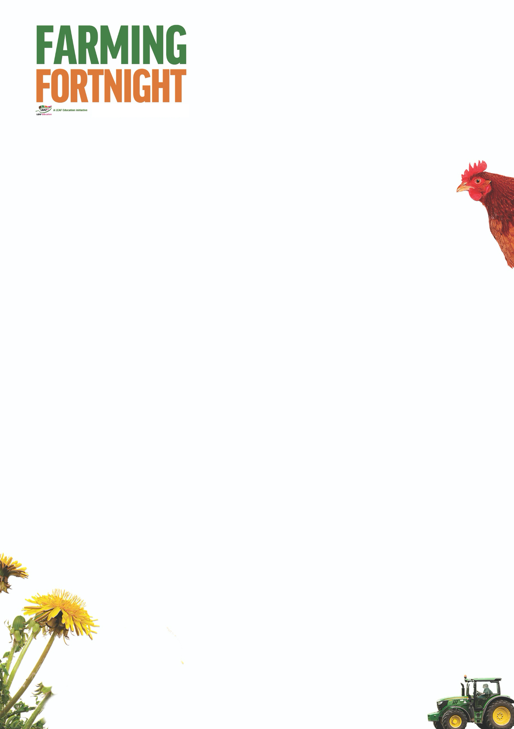
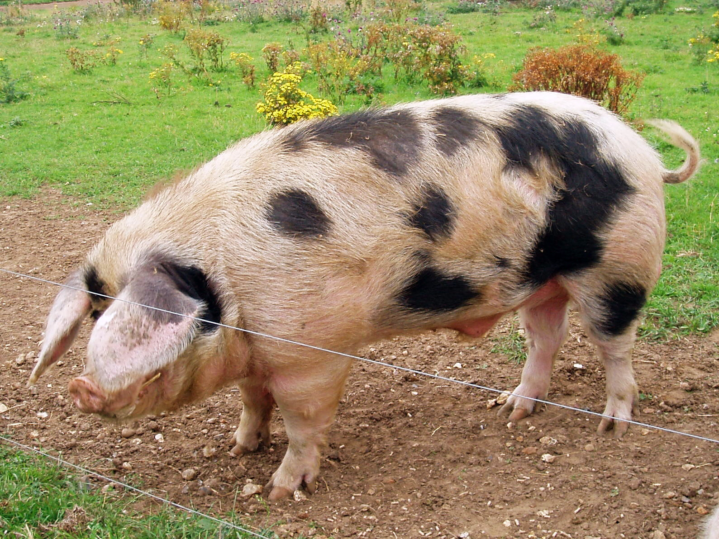
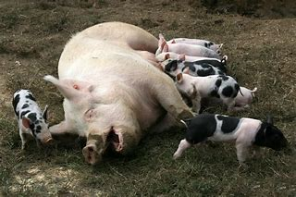
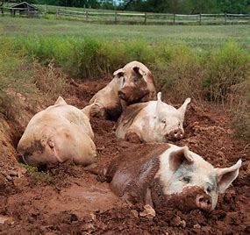
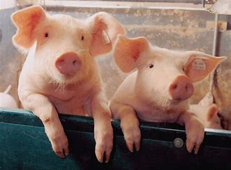


Are you getting your 5 a day?

The aim of this session is to:
- Enable pupils to categorise produce accurately, recognising when it is a fruit or a vegetable.
  - A fruit grows from the flower of a plant
  - A vegetable is another part of the plant that is edible, such as the root, stem, leaf, stalk….
- Encourage pupils to consider the fruit and vegetables being grown within the UK.
- Ensure that pupils are aware of seasonality and how modern technology enables farmers to grow food all year round whatever the season.
- Consider the factors which affect the success of fruit and vegetable harvests, and how these can be managed to minimise risk.
- Encourage pupils to think about the journey that their food has taken as it travels from field to fork;

By the end of this session, pupils will:
- Have a good understanding of the importance of fruit and vegetable production within UK agriculture and its role in managing the countryside.

The ‘Are greens always green?’ PowerPoint is designed to be used within a classroom or interactive assembly environment. Pupils are asked to consider their awareness of fruit and vegetable production within the UK and then to develop their understanding of how different foods are grown, linking the food that they eat with the countryside as a whole.

A useful resource for this session is the free poster ‘What’s in season?’ available to download here: www.whyfarmingmatters.co.uk/classroom-posters. The poster details forty-one fruits, vegetables and herbs commonly grown within the UK and which months/seasons they are available in the shops.

www.foodafactoflife.org.uk The British Nutrition Foundation have a fantastic website dedicated to enabling children to getting excited about healthy eating. Healthy Eating Week takes place in June every year - check out the website for details - and taking part in LEAF’s Farming Fortnight is a fantastic opportunity to get involved.

For further information on using farming and the countryside within education visit:
https://leafuk.org/education/leaf-education
www.countrysideclassroom.org.uk
www.whyfarmingmatters.co.uk
https://leafuk.org/farmertime/home

Are you getting your 5 a day? EYFS & KS1

What are fruit and vegetables?
Using a basket of fruit and vegetables, ask the pupils how many they can recognise, and what ones they have eaten themselves. Are there any other fruits and vegetables that are missing?

How many different ways can the pupils sort the fruit and vegetables?
- Colour
- Taste
- Grown underground or overground
- Fruit or vegetable
- Eaten cooked or raw

www.foodafactoflife.org.uk/3-5-years/where-food-comes-from/seasons
Use the downloadable season cards to explain that fruit and vegetables are grown from plants and like flowers aren’t available all year. Traditionally salads were eaten in the summer and vegetables in the winter.
Winter – parsnips and sprouts for Christmas dinner
Spring –strawberries with cream and tomatoes in sandwiches on picnics
Summer – blackberry picking straight from the bush
Autumn – pumpkins to carve and make soup from at Halloween

www.whyfarmingmatters.co.uk/classroom-posters
Use the ‘What’s in season’ poster to show how different foods are available at different times of the year. What is available in the shops now? What have they eaten recently?

Suggested activities:
Plant some cress in a variety of different containers and keep them in different places around the classroom. Which cress grows best?

Use cut outs of different fruit and vegetables to make a healthy collage of the school logo.

Undertake some market research, and use tally charts and bar graphs to display findings – What is the most popular fruit? Vegetable?

Register to take part in the free national initiative Grow Your Own Potatoes in 2020 www.growyourownpotatoes.org.uk and grow the biggest potatoes ever!

Contact your local LEAF Regional Education Consultant (education@leafuk.org) and organise for your pupils to experience fruit and vegetable farming themselves by visiting a local farm.

