

MATHS ON THE FARM
Key:
Tonne = 1000 kg
Kilogram (kg) = 1000 grams
Hectare = 10000 square metres

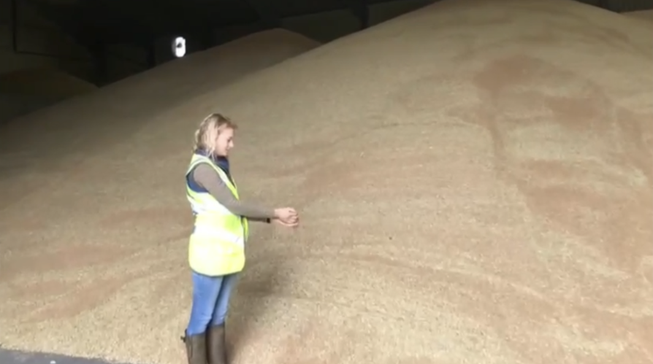
- Farmer Kate grows 160 hectares of wheat. Her normal wheat yield is 9 tonnes per hectare.
What is the total tonnage of wheat which will be stored after harvest, until some is sold in November when the price is better?
_____________________________________________________________________________________________________________________________________________________________________________________________________________________________________________

- Each bay of the grain store is 6.1 metres long, 9 metres wide and the grain can be stored up to 2.4 metres high. How many cubic metres are in each bay?
_____________________________________________________________________________________________________________________________________________________________________________________________________________________________________________

- If a cubic metre holds approximately 800kg wheat how many tonnes are in each bay? Work out to the closest tonne.
_____________________________________________________________________________________________________________________________________________________________________________________________________________________________________________

- It takes 1 kg of wheat to make 1 kg of Weetabix. How many packets of 35 Weetabix (total weight 670 grams) can be made from one bay of wheat in this store?
_____________________________________________________________________________________________________________________________________________________________________________________________________________________________________________

- The combine Harvester can cut 18 ha per day. How many dry harvest days do we need to complete the wheat harvest? Round up to the nearest number of days.
_____________________________________________________________________________________________________________________________________________________________________________________________________________________________________________

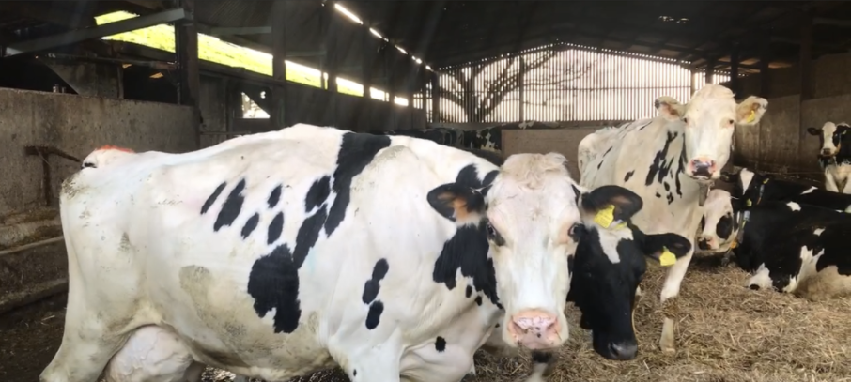

- Farmer Jimmy has 300 cows milking. The average yield per cow is 16 litres per milking. The tanker comes to collect milk once a day – how big a milk storage tank does Farmer Jimmy need?
_____________________________________________________________________________________________________________________________________________________________________________________________________________________________________________

- Cows need to eat 16kg of dry matter each per day (that’s the part of the food EXCLUDING the water contained within). Available grass is 2500kg dry matter per ha. How many ha of grass do the cows need for a day?
_____________________________________________________________________________________________________________________________________________________________________________________________________________________________________________

Mark scheme
- 160 x 9 = 1440 tonnes of wheat
- 6.1 x 9 x 2.4 = 131.76 metres squared
- 131.76 x 800 = 105,408. 105,408 ÷ 1000 = 105.408 tonnes so 105 tonnes
- 1573,000 packets
- 160 ÷ 18 = 8.89, so 9 days
- 300 x 16 = 4,800 litres
- 300 x 16 = 4, 800 kg. 4,800 ÷2500 = 1.92 fields

