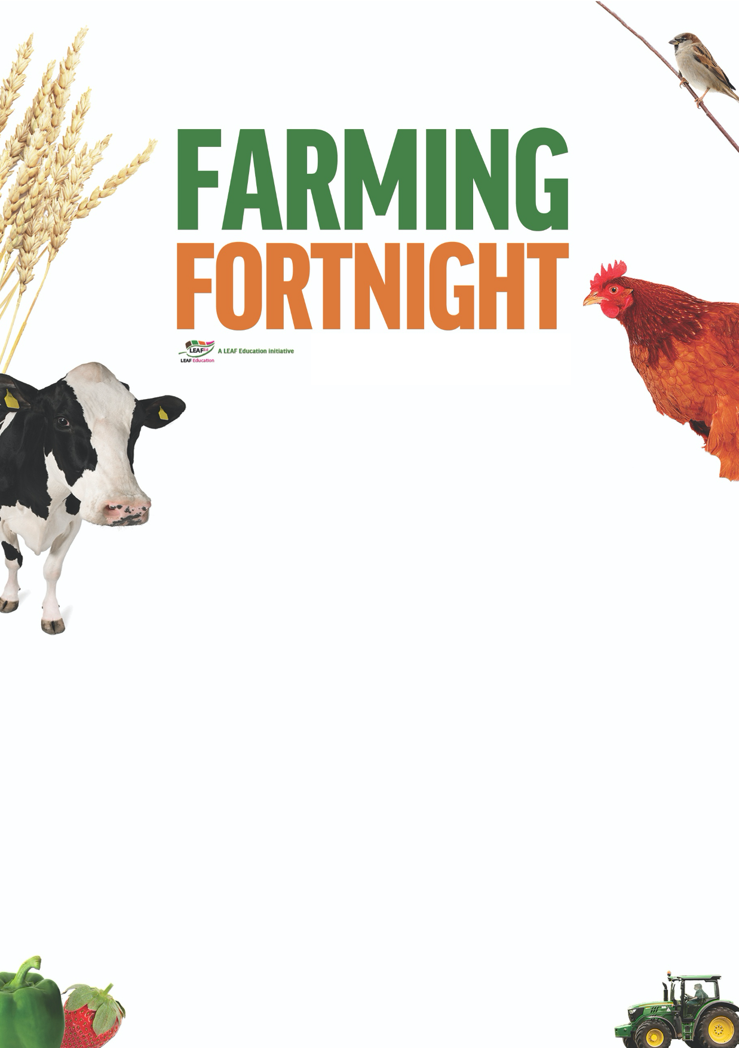
Teacher’s notes

Are you getting your 5 a day?

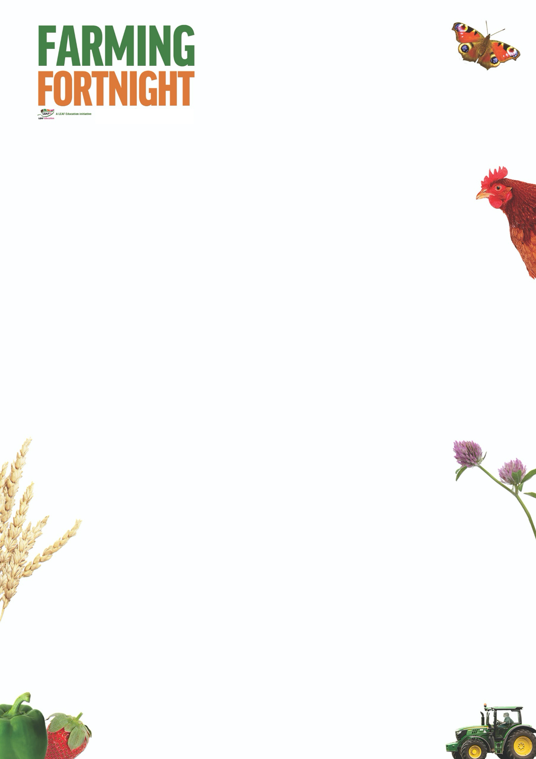
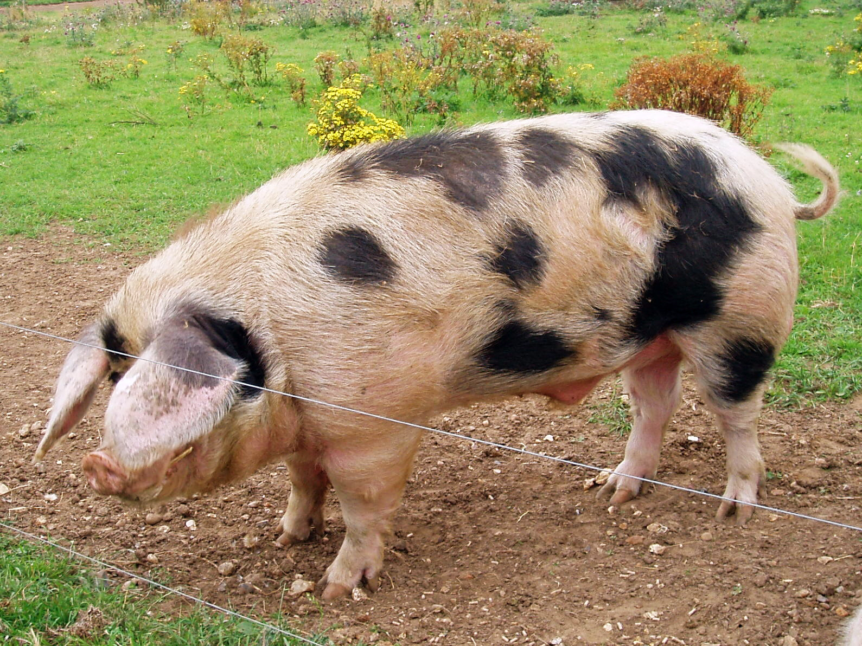
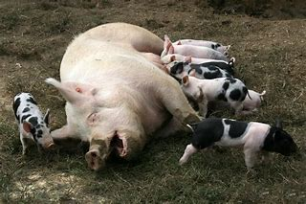
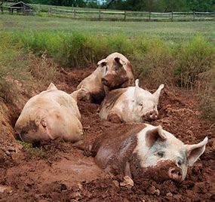
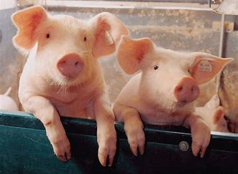


Are you getting your 5 a day?

The aim of this session is to:
- Enable pupils to categorise produce accurately, recognising when it is a fruit or a vegetable.
  - A fruit grows from the flower of a plant
  - A vegetable is another part of the plant that is edible, such as the root, stem, leaf, stalk….
- Encourage pupils to consider the fruit and vegetables being grown within the UK.
- Ensure that pupils are aware of seasonality and how modern technology enables farmers to grow food all year round whatever the season.
- Consider the factors which affect the success of fruit and vegetable harvests, and how these can be managed to minimise risk.
- Encourage pupils to think about the journey that their food has taken as it travels from field to fork;

By the end of this session, pupils will:
- Have a good understanding of the importance of fruit and vegetable production within UK agriculture and its role in managing the countryside.

The ‘Are greens always green?’ power point is designed to be used within a classroom or interactive assembly environment. Pupils are asked to consider their awareness of fruit and vegetable production within the UK and then to develop their understanding of how different foods are grown, linking the food that they eat with the countryside as a whole.

A useful resource for this session is the free poster ‘What’s in season?’ available to download here: www.whyfarmingmatters.co.uk/classroom-posters. The poster details forty-one fruits, vegetables and herbs commonly grown within the UK and which months/seasons they are available in the shops.

www.foodafactoflife.org.uk The British Nutrition Foundation have a fantastic website dedicated to enabling children to getting excited about healthy eating. Their Healthy Eating Week takes place in June every year – look at the website for details - and taking part in LEAF’s Farming Fortnight is a fantastic opportunity to get involved.

For further information on using farming and the countryside within education visit:
https://leafuk.org/education/leaf-education
www.countrysideclassroom.org.uk
www.whyfarmingmatters.co.uk
https://leafuk.org/farmertime/home

Are you getting your 5 a day? KS2

What is the difference between a fruit and a vegetable?
Pupils are encouraged to think of as many different fruits and vegetables as they can, this can include those such as bananas that are only grown abroad. Listing them on a board will help the pupils to see how many they have thought of.

Can the pupils sort these into fruit and vegetables? Why do they think that some are fruit and others aren’t?

www.whyfarmingmatters.co.uk/classroom-posters
Use the ‘What’s in season’ poster to show how different foods are available at different times of the year. What is available in the shops now? Using the ‘Are greens always green?’ power point explore how fruit and vegetables are available in the shops even when they are not traditionally ‘in season’.

Can the pupils think of any other examples of fruit and vegetables that benefit from long term bulk storage, modern farming conditions which enable them to have longer seasons, and being grown abroad and imported to the UK when not available ‘locally’?

Modern farming techniques are revolutionising fruit and vegetable farming. New technology enables farmers to grow fruit and vegetable crops in more locations, use substances other than soil to provide the vital nutrients required by the plants, use artificial light to replace sunlight and employ robots to help maximise crop yields.

Suggested activities:
Plant some cress in a variety of different containers and keep them in different places around the classroom. Which cress grows best?

Pupils choose a vegetable and in the role of the vegetable write a diary telling their story, from planting to harvest, explaining how they were transported to the shop, and how they will be eaten.

Undertake some market research, and use tally charts and bar graphs to display findings – What is the most popular fruit? Vegetable? What have they eaten recently?

Register to take part in the free national initiative Grow Your Own Potatoes in 2020 www.growyourownpotatoes.org.uk and grow the biggest potatoes ever!

Contact your local LEAF Regional Education Consultant (education@leafuk.org) and organise for your pupils to experience fruit and vegetable farming themselves by visiting a local farm.

