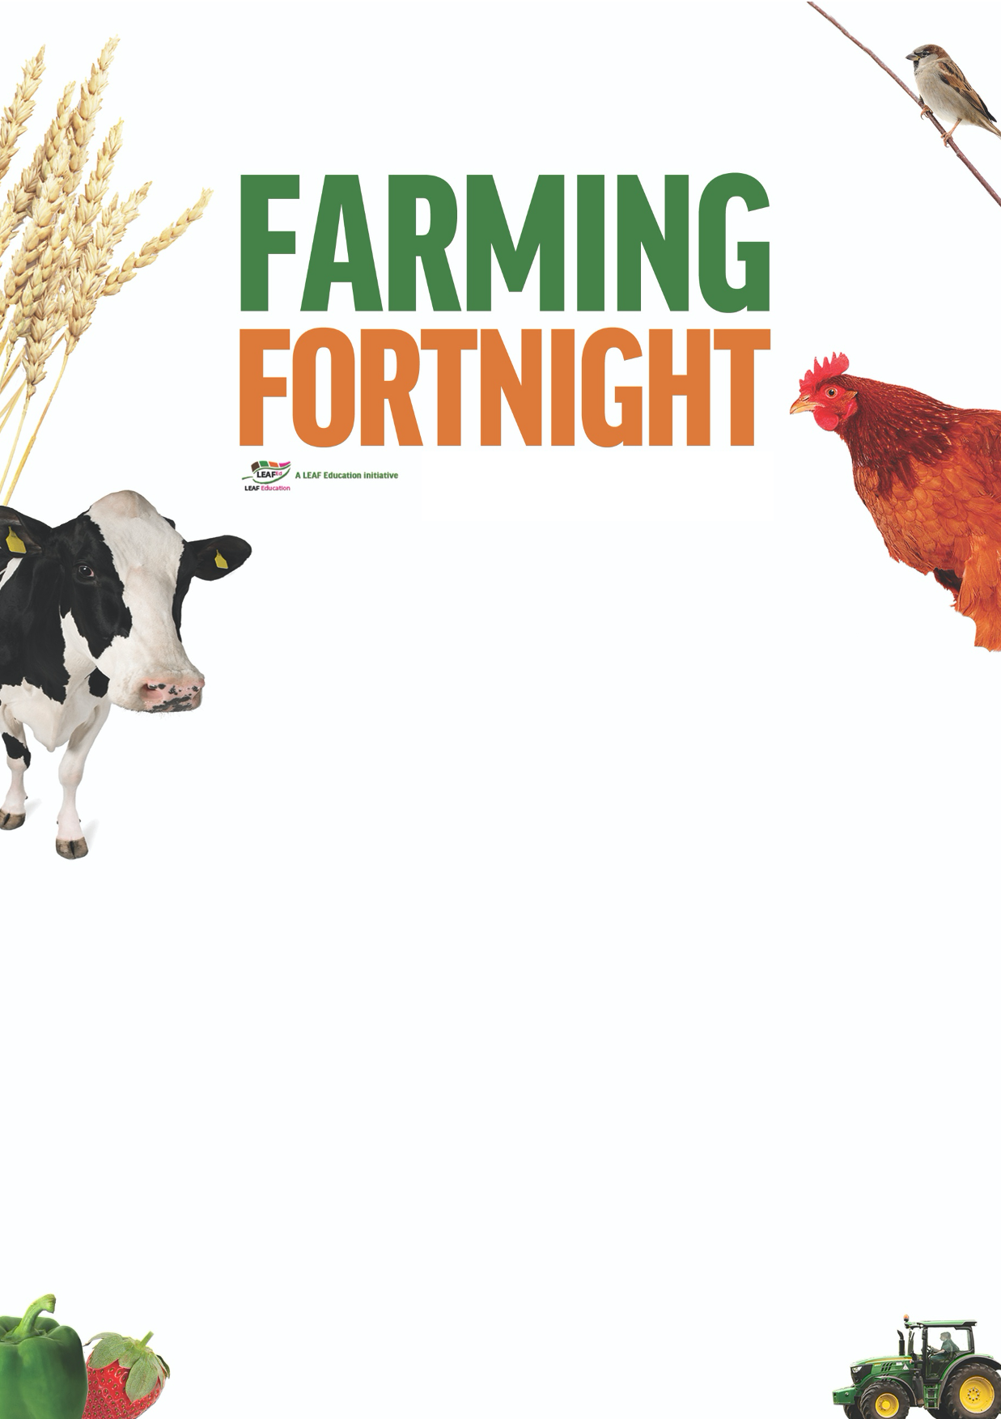
Teacher’s notes

Are you getting your 5 a day?

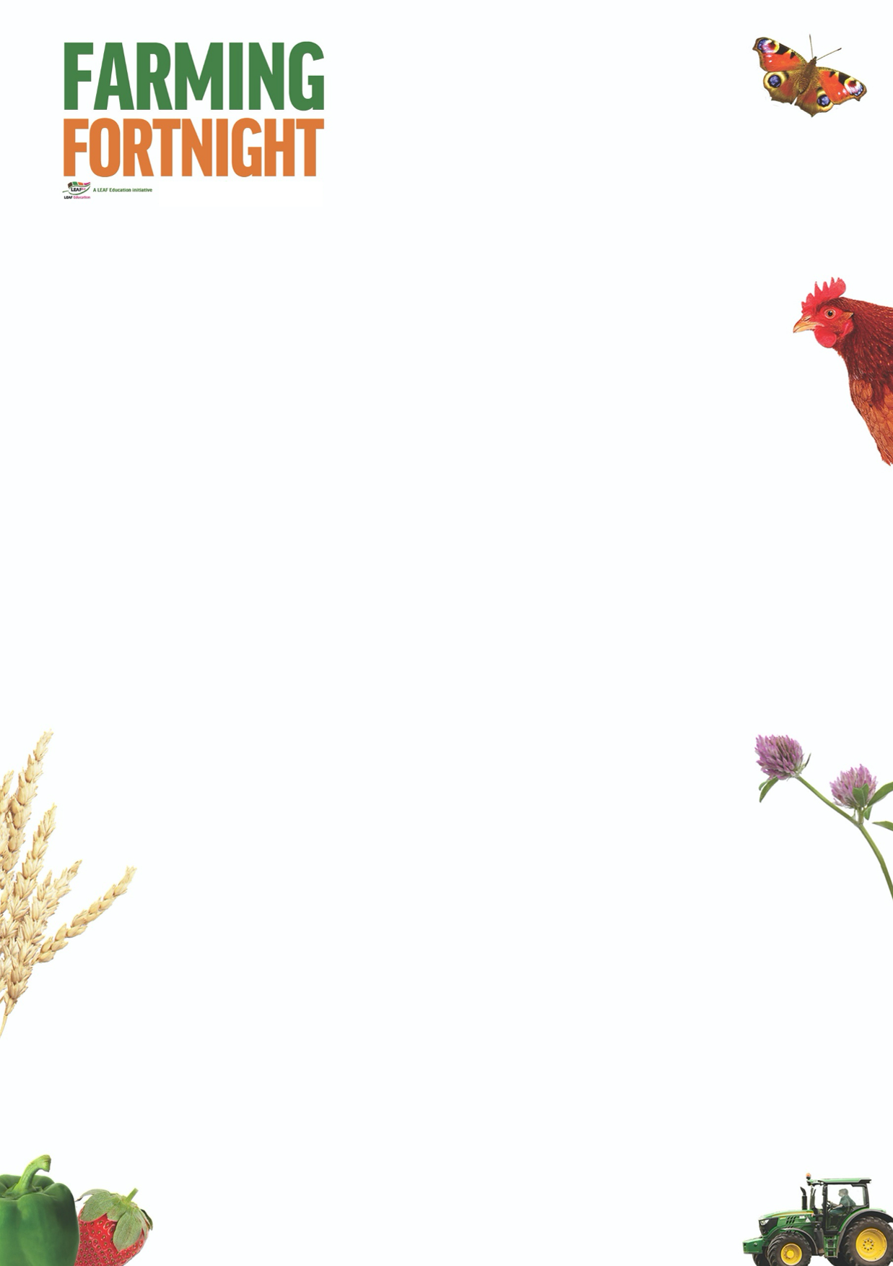
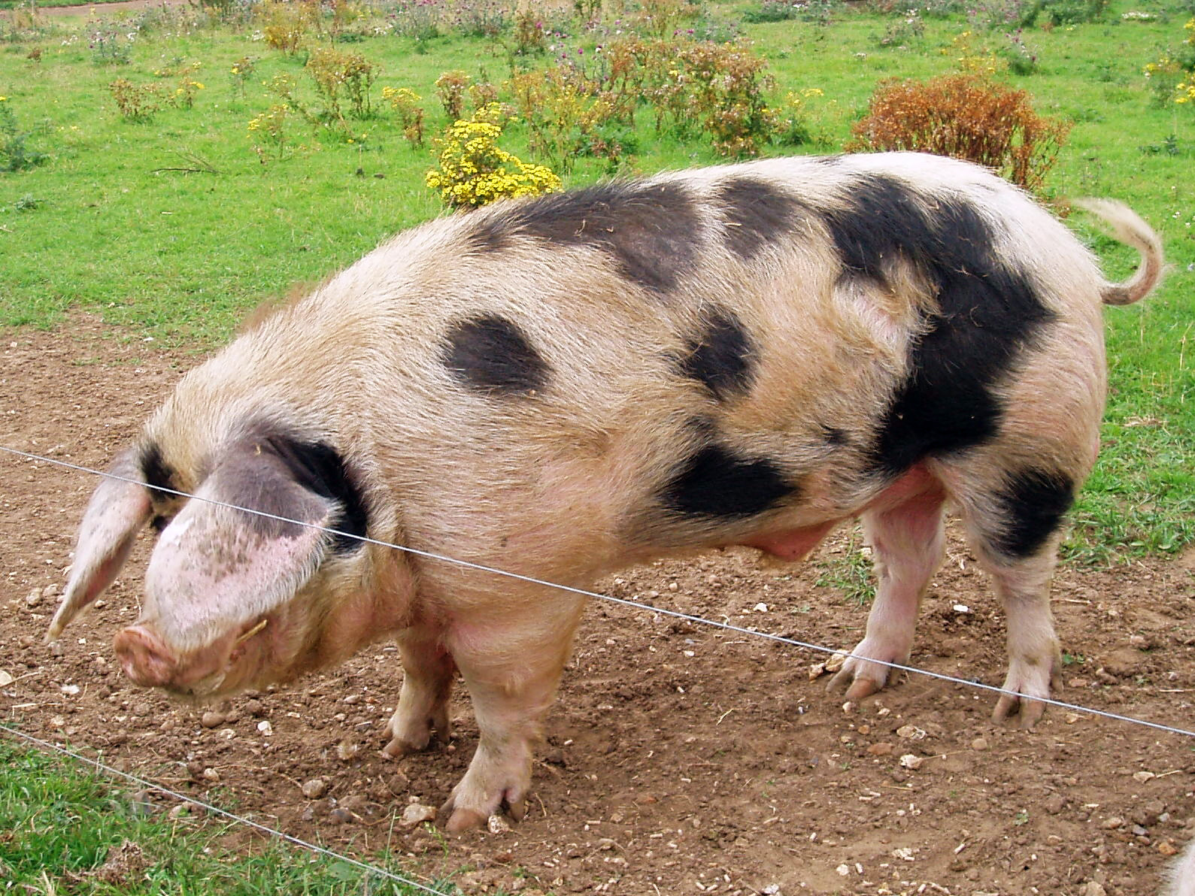
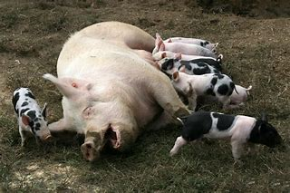
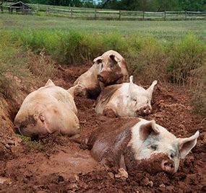
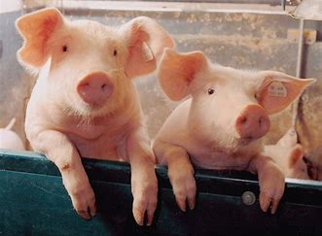


Are you getting your 5 a day?

The aim of this session is to:
- Enable students to categorise produce accurately, recognising when it is a fruit or a vegetable.
  - A fruit grows from the flower of a plant
  - A vegetable is another part of the plant that is edible, such as the root, stem, leaf, stalk….
- Encourage students to consider the fruit and vegetables being grown within the UK.
- Ensure that students are aware of seasonality and how modern technology enables farmers to grow food all year round whatever the season.
- The factors which affect the success of fruit and vegetable harvests, and how these can be managed to minimise risk.
- Encourage students to think about the journey that their food has taken as it travels from field to fork;

By the end of this session, students will:
- Have a good understanding of the importance of fruit and vegetable production within UK agriculture and its role in managing the countryside.

The ‘Are greens always green?’ PowerPoint is designed to be used within a classroom or interactive assembly environment. Students are asked to consider their awareness of fruit and vegetable production within the UK and then to develop their understanding of how different foods are grown, linking the food that they eat with the countryside as a whole.

A useful resource for this session is the free poster ‘What’s in season?’ available to download here: www.whyfarmingmatters.co.uk/classroom-posters. The poster details forty-one fruits, vegetables and herbs commonly grown within the UK and which months/seasons they are available in the shops.

www.foodafactoflife.org.uk The British Nutrition Foundation have a fantastic website dedicated to enabling children to getting excited about healthy eating. Their Healthy Eating Week takes place in June every year – check the website for details - and taking part in LEAF’s Farming Fortnight is a fantastic opportunity to get involved.

For further information on using farming and the countryside within education visit:
https://leafuk.org/education/leaf-education
www.countrysideclassroom.org.uk
www.whyfarmingmatters.co.uk
https://leafuk.org/farmertime/home

Are you getting your 5 a day? KS3/4

What is the difference between a fruit and a vegetable?
Students are encouraged to think of as many different fruits and vegetables as they can, this can include those such as bananas that are only grown abroad. Listing them on a board will help the students to see how many they have thought of.

Can the students sort those into fruit and vegetables? Why do they think that some are fruit and others aren’t?

www.whyfarmingmatters.co.uk/classroom-posters
Use the ‘What’s in season’ poster to show how different foods are available at different times of the year. What is available in the shops now? Using the ‘Are you getting your 5 a day?’ power point explore how fruit and vegetables are available in the shops even when they are not traditionally ‘in season’.

Can the students think of any other examples of fruit and vegetables that benefit from long term bulk storage, modern farming conditions which enable them to have longer seasons, and being grown abroad and imported to the UK when not available ‘locally’?

Modern farming techniques are revolutionising fruit and vegetable farming. New technology enables farmers to grow fruit and vegetable crops in more locations, use substances other than soil to provide the vital nutrients required by the plants, use artificial light to replace sunlight and employ robots to help maximise crop yields.

Suggested activities:
Undertake some market research, and display findings – What is the most popular fruit? Vegetable? What have they eaten recently? What would they like to eat more of?

www.thegrocer.co.uk/fruit-and-veg/three-quarters-of-fruit-and-veg-eaten-in-uk-is-imported/548771.article
‘Three quarters of fruit and veg in the UK is imported – read the short article and discuss what this means for consumers, retailers and UK producers of fruit and vegetables.

www.countrysideclassroom.org.uk/storage/resource/downloads/546f55e4-1770-47fb-bf5c-fd75f7c5f4fe/original/migrant-workers-2018.pdf
Referring to the data and information contained in the Leaf Education publication entitled ‘Migrant workers’ use the short activities to encourage students to explore the role of migrant workers within the fruit and vegetable industries.

Contact your local LEAF Regional Education Consultant (education@leafuk.org) and organise for your pupils to experience fruit and vegetable farming themselves by visiting a local farm.

